Dear [Name of Candidate],
Congratulations on being chosen to be a Parliamentary Candidate. This letter comes to you by way of the Nuclear Weapons Group of Medact which is the UK affiliate of 1985 Nobel Prize-winning International Physicians for the Prevention of Nuclear War (IPPNW).
Putin’s invasion of Ukraine and the ongoing catastrophic Israeli bombardment of Gaza have reignited long standing calls for nuclear disarmament for the prevention of nuclear war.
The debate has always been polarised and emotionally charged, but the following questions capture the issue (see Appendix 1):
- Would a global nuclear war result in the destruction of human civilisation?
- Is the nuclear deterrence system capable of failure?
- Is it possible for humanity to reduce the number of nuclear weapons existing in our world to zero?

There is compelling evidence that the answer to all of these questions is an unambiguous yes. The reasons for this are set out in the appendices to this letter. As a candidate who aims to represent my constituency in Parliament, I would be very grateful if you would give your personal answers to each of the three questions.

Subsequently, please indicate your commitment to advocating for the United Kingdom to sign and ratify the Treaty for the Prohibition of Nuclear Weapons (TPNW) and join the process towards global nuclear disarmament. At the very least, the UK should aim to attend the Third Meeting of States Parties to the TPNW on 3 to 7 March 2025 at United Nations Headquarters in New York as an observer. States that have not yet become a party to the TPNW can attend meetings of states parties as observers, to view the proceedings and, if it wishes, contribute to the debates by making statements or submitting papers.

Many thanks for responding to these questions, and thank you for putting so much time and energy into this General Election. I look forward to hearing from you.

Best wishes,

[Name and address of constituent]

APPENDIX 1

APPLYING CLEAR LOGIC TO NUCLEAR DETERRENCE
The Inventor’s Paradox is an approach to problems that starts by taking a view of the whole situation, looking at the principle before diving into the details. If we can arrive at certainty at the general level, we can then apply this certainty to the specific problem.

It can be very useful where the debate is encumbered with preconceived ideas and emotion, as is the case with the nuclear weapons debate.

It is true to say that
“If the consequences of the failure of a system would be totally destructive to civilisation,
it is reasonable for humans to use that system if, and only if, the probability of its failure is zero”.

The statement is clear and easy to understand because it is general. If the failure of a system means 100% destruction, we may use it only if there is a ZERO chance of failure. Everyone can understand that.

Acceptance of the general truth avoids all the prejudices associated with the deterrence argument.

We then apply this general truth to the Nuclear Deterrence system, and it becomes clear that we can only use it if there is a ZERO chance of failure. Can it fail? Yes it can. Therefore we must go for Global Zero.
The statement gives power to the subsequent questions

APPENDIX 2

WOULD THE USE OF NUCLEAR WEAPONS WOULD BRING ABOUT THE END OF HUMAN CIVILISATION?

There is an important preliminary question attached to this, which is:
Would it be possible to get away with a limited exchange, or would one nuclear detonation inevitably escalate into an all-out global nuclear war?
It is impossible to give a definitive answer to that question, but the only safe assumption to make is that if one weapon is detonated, there is a real possibility that a global nuclear war will ensue. The reason for this lies in the nuclear deterrence doctrine of first strike, which aims to destroy the opponent’s weapons before they can be fired. Once it is known that an opponent has detonated a nuclear weapon, the pressure will be on for supreme commanders to fire all their nuclear weapons before they lose them to a first strike, and in an effort to destroy the opponent’s remaining nuclear weapons. Although we cannot say that any exchange would inevitably lead to a first strike, it would be the height of folly for anyone to assume that they could use weapons in a limited tactical strike and believe that matters would then be allowed to rest by the opposition.
Unfortunately this limited tactical strike idea is the prevailing nuclear doctrine of the USA, Russia and other nuclear weapons states.

They consider that nuclear weapons could be used tactically, as an extension of a conventional military campaign.

Therefore the answer here is, no, it would not be possible to get away with a limited exchange: we must assume that one nuclear detonation would in all likelihood escalate into an all-out global nuclear war.

So now for the main question:

Would an all-out strategic nuclear exchange be infinitely destructive to human civilisation?
The answer here is a confident YES.

The effects of all-out nuclear war have been comprehensively studied. It is known that in a nuclear war, millions of us would die immediately of blast injuries, crush injuries, and burns. Millions more would die more slowly of radiation sickness, infections, lack of effective medical care, and, eventually, starvation.

There are estimated to be at least 13,000 nuclear weapons in the world held by at least 9 countries, most of them held by the United States and Russia.

Toon et al in 2019 estimate that even a limited nuclear war between India and Pakistan involving about 250 nuclear bombs could bring about significant global cooling, where atmospheric soot from fires caused by the bombs would cut off sunlight for a period. This being so, the use of the global stockpile of 13,000 nuclear weapons would without doubt cause a “nuclear winter” lasting weeks, months or even years. This will cause wintry temperatures throughout the year, across much of the planet. Absence of sunlight will mean crop failures and therefore starvation.

When sunlight returns, the effects of city and forest fires will significantly increase the atmospheric CO2 load, exacerbating global warming. Species loss will increase, secondary to habitat loss. Of these, the loss of bees will be most important since cessation of their pollination services will lead to failure of such crops as survivors may try to plant.
Economic growth after a global nuclear war would be very unlikely, to say the least. In fact, a deep global economic depression is inevitable, so our civilisation will be replaced by a survival economy based around obtaining water, food, warmth, and shelter for the local group. Life would be short, cancers plentiful, health services would be rudimentary or non-existent, with analgesics, antibiotics, and other essential medicines in very short supply.

Self-interest is likely to become the prevailing ethical norm, and government would be by gangsterism and rule by war-lords.
In summary, it is entirely reasonable to expect that an all-out nuclear exchange would lead to the end of human civilisation.

In terms of the syllogism set out at the beginning, the consequences of the failure of a nuclear deterrence system would indeed be infinitely destructive to our civilisation.

So the next question is this:

Is the probability of deterrence failure greater than zero?
The answer here is unfortunately also a confident YES
See Appendix 2

APPENDIX 3
IS THE NUCLEAR DETERRENCE SYSTEM CAPABLE OF FAILURE?

Nuclear deterrence is a complex system comprising electronic sensors embedded in a command and control network composed of humans who are working to protocols interwoven with pattern judgments and evaluations which are affected by the emotional state of the individuals and groups that make the judgments.

The groups themselves, particularly the supreme decision-making groups, are isolated from the body of humanity, and are known to be susceptible to a condition known as groupthink – defined as a mode of thinking that people engage in when they are deeply involved in a cohesive in-group, when the members' strivings for unanimity override their motivation realistically to appraise alternative courses of action. Moreover, the interplay of decision makers is now far more complex than in the days of the Cold War, with nuclear-armed players coming onto the field who might not view the destruction of the prevailing world civilisation as a thing to be avoided at all costs, and we have other players already on the scene who believe that nuclear weapons could be used tactically without risking a strategic exchange.

There have already been at least 9 instances where the world came perilously close to nuclear war.

A time of global political tension and crisis, it is entirely possible that a stressed President or Prime Minister faced with a complex web of global and national crises, encountering false information from an error within the electronic detector system, could decide that a nuclear war was the only option.

In conclusion, it is entirely reasonable to judge that the probability of failure of the nuclear deterrence system is greater than zero.

Since the conditions of the syllogism at the beginning of this paper have been matched, it is necessary for us to work to bring about a condition of zero nuclear weapons being held in our world.

Is global elimination of nuclear weapons a pipe dream, or is it feasible?

APPENDIX 4
IT IS POSSIBLE TO OBTAIN A GLOBAL ZERO OF NUCLEAR WEAPONS?

Background

The quantity of nuclear weapons has already been significantly reduced.

The START I Treaty came into force in 1994 and has been extended twice, with the current START III due to end in 2026.

Before this treaty, the USA and Russia had about 60,000 nuclear weapons between them. Now the figure is nearer 10,000.

This figure shows the approximate stockpiles in the world over time, showing the dramatic reduction produced by START, which should give us hope that further reductions are possible.

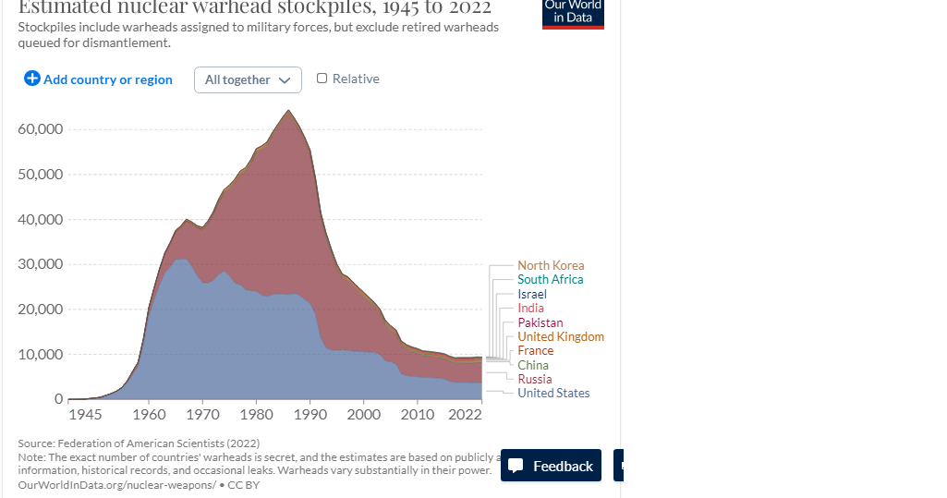

The Nuclear Non-Proliferation Treaty (NPT) has been in force since 1974. Unfortunately, the Nuclear Weapons States have not met their obligation under Article 6 of the Treaty to “pursue negotiations in good faith on effective measures relating to cessation of the nuclear arms race at an early date and to nuclear disarmament, and on a Treaty on general and complete disarmament under strict and effective international control".

The Treaty on the Prohibition of Nuclear Weapons (TPNW) came into force in January 2021, and effectively makes the possession of nuclear weapons illegal. The Nuclear Weapons States (NWS) are ignoring the TPNW at present.

The NWS are a tiny minority of the 193 states which comprise the United Nations, and as time goes by they will begin to feel their isolation more acutely.

Intensive diplomacy and consciousness raising is necessary before leaders will begin to work on a plan to reduce the number of nuclear weapons on the planet to zero, but once they start to apply themselves to this vital task, the action plan is relatively simple.

APPENDIX 4 (CONT)
CONFIDENCE BUILDING

Intensive diplomacy and consciousness raising is necessary before leaders will begin to work on a plan to reduce the number of nuclear weapons on the planet to zero, but once they start to apply themselves to this vital task, the action plan is relatively simple.

GLOBAL ZERO ACTION PLAN
The Global Zero Organisation have developed a clear pathway that leads to the total abolition of nuclear weapons by all sides, whose details can be found here: https://www.globalzero.org/reaching-zero/
In brief, it consists of the following four steps:
Phase I
Russia and the U.S. cut their nuclear arsenals from over 5,000 warheads each to 1,100 warheads each.

Nuclear-armed states engage in direct talks to strengthen global stability, reduce nuclear risks, and set the stage for further arsenal cuts.
Nuclear-armed states commit to never using nuclear weapons first.

Phase II
Russia, the U.S., and China cut their nuclear arsenals to 300 warheads each.
All other nuclear-armed states agree to not exceed this limit.

Nuclear-armed states continue direct talks to further global stability, strengthen monitoring and verification, and develop a framework for the Global Zero Accords.

Phase III
All nuclear-armed states negotiate, sign and ratify the Global Zero Accords, a binding international treaty that removes all nuclear weapons from military service within two years, and requires the complete destruction of nuclear warheads by 2045.

Phase IV
All remaining nuclear weapons are removed from military service within two years of the Global Zero Accords entry into force, and all nuclear weapons are dismantled by 2045.
Universal prohibition, verification, and enforcement continues.
Finally, Article 4 of the TPNW provides the official mechanism for the Action Plan to be implemented.
https://ihl-databases.icrc.org/en/ihl-treaties/tpnw-2017/article-4?activeTab=undefined

IN CONCLUSION, the use of nuclear weapons results in the destruction of human civilisation, the nuclear deterrence system capable of failure, and it is possible for the international community to eliminate, totally, the presence of nuclear weapons from the world.

Medact Nuclear Weapons Group

https://www.livescience.com/how-many-nuclear-weapons-exist
https://www.ncbi.nlm.nih.gov/pmc/articles/PMC6774726/
https://www.science.org/doi/10.1126/science.222.4630.1283
Janis, Irving L. Victims of Groupthink. Boston. Houghton Mifflin Company, 1972, page 9.
https://www.sciencealert.com/near-misses-nuclear-war-history-cold-war-radar-missiles
Lachlan Forrow and others, "Accidental Nuclear War --A Post Cold War Assessment," NEW ENGLAND JOURNAL OF MEDICINE Vol. 338, No. 18 (April 30, 1998), pgs. 1326-1331

